# PREREQUISITES

TEAM ID : PNT2022TMID07793

TITLE : Real time river water quality monitoring and control system

# IBM CLOUD

TEAM LEADER

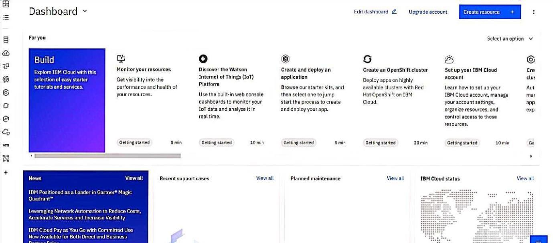

TEAM MEMBER-2

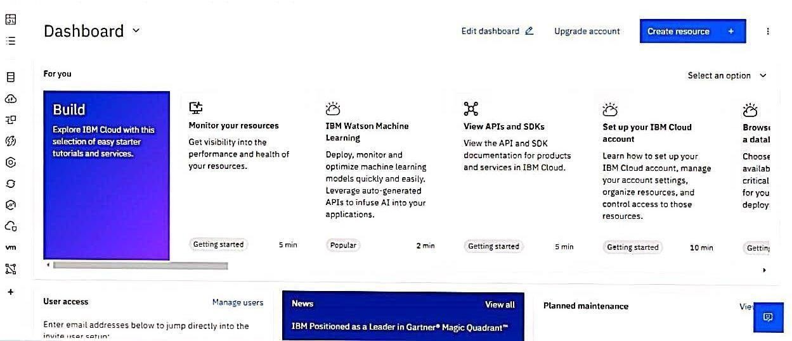

TEAM MEMBER-3

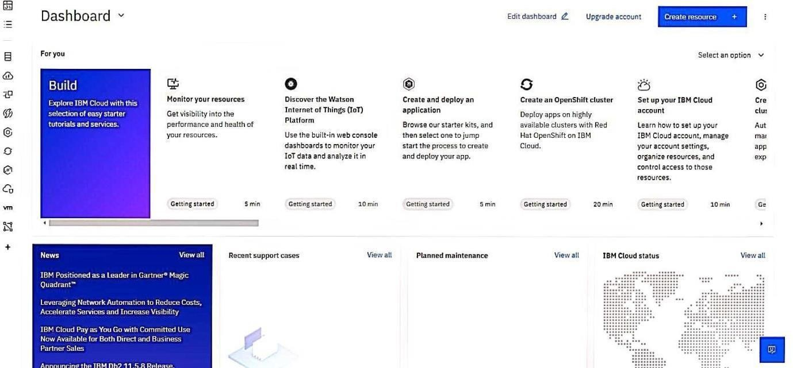



TEAM MEMBER-4

PYTHON INSTALLATION

TEAM LEADER TEAM MEMBER-2

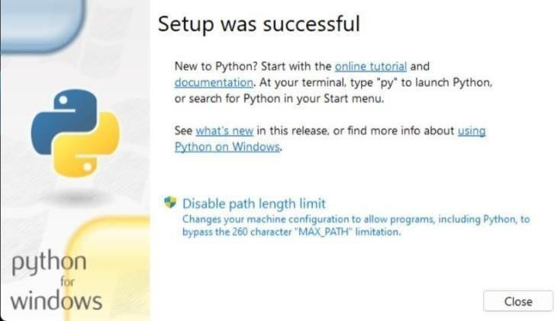

**TEAM MEMBER-3 TEAM MEMBER-**

FAST2SMS INSTALLATION

TEAM LEADER

TEAM MEMBER-2

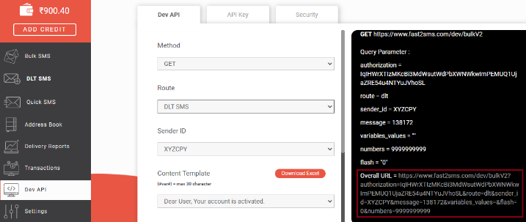 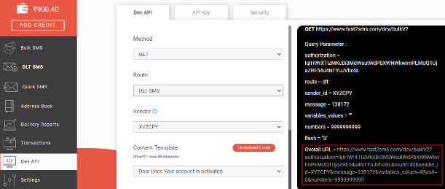

TEAM MEMBER-3 TEAM MEMBER-4

